Molinero, J.C. F. Ibanez, P. Nival, E. Buecher, and S. Souissi. 2005. North Atlantic climate and northwestern Mediterranean plankton variability. Limnol. Oceanogr. 50: 1213-1220.

Sirabelli, P., A. Giuliani, A. Colosimo, and J. Dippner. 2001. Breaking down the climate effects on cod recruitment by principal components analysis and canonical correlation. Mar. Ecol. Progr. Ser. 216: 213-222.

PROJECT DESCRIPTION

I. Results from Prior NSF Support

Title: U.S. GLOBEC: Broad-Scale and Time Series Acoustic Measurements of
Zooplankton and Nekton in the Georges Bank Region (NSF OCE-9313675)
Principal Investigators: Peter Wiebe, Timothy Stanton, and Charles Greene
Project Duration: 3/1/95-2/28/97 Award Amount: $399,477

Title: U.S. GLOBEC: Processes controlling the recruitment of Calanus finmarchicus
populations from the Gulf of Maine to Georges Bank (Jointly funded by NSF and NOAA; Cooperative Agreement NA-67RJO148)
Principal Investigators: Charles Greene, Mark Benfield, and Peter Wiebe
Project Duration: 1/1/97-6/30/01 Award Amount: $645,846

Title: U.S. GLOBEC: Broad-Scale Patterns of the Distribution of Zooplankton and Nekton
in Relation to Micro-, and Coarse-scale Physical Structure in the Georges Bank Region (supplement to NSF OCE-9313675)
Principal Investigators: Peter Wiebe, Timothy Stanton, and Charles Greene
Project Duration: 2/15/98-1/31/99 Award Amount: $90,000

In addition to the above grants, Charles Greene was supported during 2000/2001 as a sabbatical fellow at the National Center for Ecological Analysis and Synthesis (NCEAS), a center jointly funded by NSF and the University of California, Santa Barbara.

The most significant scientific result derived from the above research has been our ability to link the order of magnitude reduction in C. finmarchicus abundance observed in the Gulf of Maine during autumn 1998 (relative to autumns of 1997 and 1999) to a North Atlantic Oscillation (NAO)-driven modal shift in the Northwest Atlantic’s coupled slope water system (Greene and Pershing, 2000; MERCINA, 2001; 2003; 2004). Retrospective analyses of continuous plankton recorder and hydrographic time-series data have enabled us to place this result in the context of climate-driven changes in ocean circulation observed over the past 50 years in the Northwest Atlantic. This research has led to 1.) the organization of several special symposia and workshops, 2.) the presentation of several invited talks at international symposia, 3.) the publication of 20 scientific papers, and 4.) the training and thesis research of numerous graduate and undergraduate students.

A. Special Symposia and Workshops:

The Response of Northeast and Northwest Atlantic Shelf Ecosystems to Climate Variability and Change. ASLO Summer Meeting, Copenhagen, Denmark; June 2000. Organizers: Charles Greene and Benjamin Planque.

Response of Northwest Atlantic Marine Ecosystems to Climate Variability. NCEAS, Santa Barbara, CA; Spring 2001. Organizer: Charles Greene.

Marine Ecosystem Responses to Climate: The Responses of Large Marine Ecosystems to Interdecadal-Scale Climate Variability. ASLO/AGU Ocean Sciences Meeting, Honolulu, HI; February 2002. Organizers: Charles Greene, Michael Fogarty, and Nathan Mantua.

B. Invited Talks at International Symposia:

Greene, C.H., and A.J. Pershing. The response of Calanus finmarchicus populations to climate variability in the Northwest Atlantic: basin-scale forcing associated with the North Atlantic Oscillation. ICES Symposium: Population Dynamics of Calanus in the North Atlantic, Tromso, Norway; August 1999.

Greene, C.H., and A.J. Pershing. Trans-Atlantic responses of Calanus finmarchicus to basin-scale forcing associated with the North Atlantic Oscillation. AGU Chapman Conference on the North Atlantic Oscillation, Ourense, Spain; November 2000.

Greene, C.H., and A.J. Pershing. Trans-Atlantic responses of Calanus finmarchicus to basin-scale forcing associated with the North Atlantic Oscillation. 70th Anniversary of the Continuous Plankton Recorder Surveys of North Atlantic Symposium, Edinburgh, Scotland; August 2001.

Greene, C.H., and A.J. Pershing. Biocomplexity and climate: recovery of the North Atlantic Right Whale population in the context of climate-induced changes in oceanographic processes. Climate Change and Aquatic Systems Symposium, Plymouth, England; July 2004.

C. Publications Citing Previous US GLOBEC Support:

The following 20 publications cite previous US GLOBEC support through the above grants: Barton et al. (2003); Benfield et al. (1998, 2003); Drinkwater et al. (2002); Greene et al. (1998a, b, c, d, 2003); Greene and Pershing (2000, 2003, 2004); MERCINA (2001, 2003, 2004); Pershing et al. (2004, 2005); Wiebe et al. (1996, 1999, 2002).

D. Educational Outcomes from Previous US GLOBEC Support:

US GLOBEC provided support for the following graduate thesis research: Andrew Barton (Cornell MS 2001: Continuous plankton recorder survey phytoplankton measurements and the North Atlantic Oscillation: interannual to multidecadal variability in the Northwest Shelf, Northeast Shelf, and Central North Atlantic Ocean), Andrew Pershing (Cornell PhD 2001: Response of large marine ecosystems to climate variability: patterns, processes, concepts, and methods), Karen Fisher (Cornell PhD 2002: Intermittency of spatial and temporal plankton patterns), and Joseph Warren (WHOI/MIT PhD 2001: Estimating Gulf of Maine zooplankton distributions using multiple frequency acoustic, video and environmental data). Seven Cornell undergraduates conducted related research in our laboratory during this time frame, resulting in two honors theses.

II. Proposed Research

A. Introduction

Understanding the variability observed in marine ecosystems, especially the large fluctuations in abundance and recruitment of exploited fish stocks, has been a major goal of oceanographers and fisheries scientists since the late 19th century (reviewed by Cushing, 1982; 1996). For many years, researchers have noted that fluctuations in fish populations are often associated with dramatic regime shifts in marine ecosystems (de Young et al., 2004). One of the earliest recognized and most famous of these regime shifts is the Russell Cycle, which was first observed as a shift in the English Channel's plankton community during the late 1920's that was subsequently observed to reverse itself during the late 1960's (Cushing and Dickson, 1976; Cushing, 1982). The Russell Cycle was characterized by dramatic changes in nutrient concentrations as well as the species composition and relative abundances of phytoplankton, zooplankton, and fish. A key commonality between the Russell Cycle and other fluctuations observed in North Atlantic fisheries is their link to basin-scale changes in North Atlantic climate (Dickson et al., 1988; Cushing, 1996; Conover et al., 1995; Attrill and Power, 2002).

The major basin-scale mode of inter-annual to inter-decadal climate variability in the North Atlantic Ocean is the North Atlantic Oscillation (NAO) (Hurrell et al., 2003). The NAO oscillates between two characteristic phases and is typically quantified by the NAO Index (Hurrell, 1995). Positive values of the NAO Index correspond to enhanced pressure differences during winter between centers of the two major atmospheric pressure systems in the North Atlantic, the Azores' High and Icelandic Low; negative values correspond to reduced pressure differences between these two atmospheric centers of action (Jones et al., 2003). Phase changes in the NAO have been linked to basin-scale changes in heat transport, precipitation, storm track, and wind field patterns as well as major reorganizations of ocean circulation (Hurrell et al., 2003; Visbeck et al., 2003). These phase changes also have been correlated with significant regional responses of marine ecosystems on both sides of the North Atlantic, including the Baltic Sea (Hanninen et al., 2000); Barents Sea (Ottersen and Stenseth, 2001); Bay of Biscay, Celtic Sea and English Channel (Beaugrand et al., 2001); North Sea (Reid et al., 2001); Georges Bank (GB) (MERCINA, 2004), Gulf of Maine (GOM) (MERCINA, 2001; 2003), and Scotian Shelf (SS) (Sameoto, 2001; 2004). The abundance and recruitment of commercially important fish stocks in these ecosystems also have been correlated with phase changes in the NAO (Attrill and Power, 2002; Drinkwater et al., 2003).

In addition to the NAO, there are other natural and anthropogenic sources of basin-scale climate variability in the North Atlantic. As we enter the twenty-first century and face the likelihood of climatic changes unprecedented in human history (IPCC, 2001), society should anticipate changes in the structure and function of the ecosystems on which we have come to depend. For marine ecosystems, scientists confront a daunting challenge – we must take our modest understanding of marine ecosystem responses to previously observed changes in climate and try to develop models capable of forecasting the fate of these ecosystems and their living resources in a future shaped by both natural as well as anthropogenic climate forcing. During the past decade, the United States Global Ocean Ecosystem Dynamics (US GLOBEC) Northwest Atlantic/GB Program has made significant advances in our understanding of the linkages between climate and marine ecosystems in the Northwest Atlantic (Conversi et al., 2001; MERCINA, 2001; 2003; 2004; Wiebe et al., 2002b). Here, we propose to take the understanding gained from that past decade of research, expand upon it, and use this expanded knowledge as a basis for providing operational input to the resource managers of the Northeastern United States.

B. Hypotheses

Until very recently, many oceanographers and climate scientists have expressed serious concerns about the potential for abrupt climate change and dramatic cooling in northern Europe during the 21st century (e.g., Broecker, 1997; Rhamstorf, 1997). The hypothesized scenario underlying these concerns suggests that increased ice melting and freshwater discharge brought about by greenhouse warming might 1.) disrupt North Atlantic Deepwater formation, 2.) diminish Atlantic Meridional as well as the Global Overturning Circulation, and 3.) reduce oceanic heat transport to the Northeast Atlantic and northern Europe. It has also been suggested that such changes may dramatically impact marine ecosystem productivity worldwide (Schmittner, 2005). More recent climate-change models and hypotheses have downplayed the likelihood of this scenario, at least in the near future, as North Atlantic Deep Water formation in the Greenland Sea appears to be less sensitive to the kinds of buoyancy forcing anticipated over the next century (Wood et al., 1999; Weaver and Hillaire-Marcel, 2004). However, these same climate-change models suggest that the Labrador Sea may be a region that is especially sensitive to the effects of greenhouse warming and its associated surface-water freshening (Wood et al., 1999; Hillaire-Marcel et al., 2001; Weaver and Hillaire-Marcel, 2004). Given this newly recognized sensitivity and its role as the buoyancy-driven center of forcing in the Northwest Atlantic, the Labrador Sea may soon be viewed by climate scientists as the most likely driver of significant climate change in the North Atlantic during the 21st century. Through understanding the Labrador Sea’s direct and remote forcing of ocean circulation patterns, oceanographers may find the key to assessing the impacts of climate change on the marine ecosystems of the Northwest Atlantic. Hence, one of the major goals of our proposed research is to assess the role of remote upstream forcing from the Labrador Sea on ecosystems processes in the Northwest Atlantic. In previous studies, we have provided evidence for the hypothesis that remote forcing from the Labrador Sea, as mediated by the Coupled Slope Water System (CSWS) (Pickart et al., 1999), impacts ecosystem processes in the SS/GOM/GB region (MERCINA, 2001; 2003; 2004). In the studies proposed here, we will expand the scope of this earlier research to examine the following hypotheses:

- Remote forcing of ecosystem processes in the SS/GOM/GB region is mediated not only by the CSWS but also through the enhanced transport of lower salinity shelf waters derived from upstream sources, including the Labrador Sea.

- Remote forcing from the Labrador Sea impacts ecosystem processes not only in the SS/GOM/GB region but also in the Middle Atlantic Bight (MAB).

C. Research Plan/Methods

In describing our research plan, we will detail what we have learned from previous synthesis studies about regional responses to climate variability from the SS to GB and the methods that we used to achieve this knowledge. Since our hypotheses arose in the context of these previous studies, this comparative approach should provide the reviewer with a clearer understanding of what we hope to learn in the coming years and the methods that we propose to employ.

Hypothesis 1: Remote forcing of ecosystem processes in the SS/GOM/GB region is mediated not only by the CSWS but also through the enhanced transport of lower salinity shelf waters derived from upstream sources, including the Labrador Sea.

The region of the Northwest Atlantic shelf extending from the SS to GB lies within a shifting oceanographic transition zone, located between cold subpolar waters influenced by fluctuations in the Labrador Current to the northeast and warm temperate waters influenced by fluctuations in the Gulf Stream to the south (Loder et al., 2001; MERCINA, 2001). The transitions that occur within this zone are not only physical, as reflected by hydrographic changes, but also biological, as reflected by changes in the composition and relative abundance of plankton (Greene and Pershing, 2000; MERCINA, 2001; 2003; Sameoto, 2001). The shifting nature of this transition zone makes the region especially vulnerable to climate-driven changes in North Atlantic circulation (GLOBEC, 1992).

The region’s physical responses to changes in ocean circulation are often mediated by the Northwest Atlantic’s CSWS (Pickart et al., 1999; MERCINA, 2001). Two characteristic modes have been identified for the CSWS. The maximum mode of the CSWS corresponds to a state in which Labrador Current transport around the tail of the Grand Banks is reduced, and the frontal boundary of relatively cool, fresh Labrador Subarctic Slope Water (LSSW, previously referred to as Labrador Slope Water) extends only as far as the Gulf of St. Lawrence (Fig. 1A). The minimum mode corresponds to a state in which Labrador Current transport around the tail of the Grand Banks is intensified, and the frontal boundary of LSSW advances further downstream along the continental margin, displacing warmer, saltier Atlantic Temperate Slope Water (ATSW, previously referred to as Warm Slope Water) offshore (Fig. 1B).

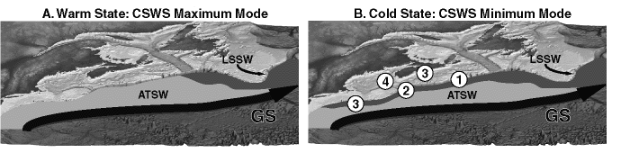
Figure 1. Distribution of LSSW (dark gray) and ATSW (light gray) during the maximum (A) and minimum (B) modal states of the CSWS. The circled numbers indicate the observations of LSSW following the 1996 NAO event: 1 = September 1997, 2 = January 1998, 3 = February 1998, 4 = August 1998. Redrawn from Greene and Pershing (2003).
Recently, it has been shown that modal shifts in the CSWS are often associated with phase changes in the NAO (MERCINA, 2001). From 1975 to 1999, the NAO Index was predominantly positive (Hurrell et al., 2003), and the CSWS usually exhibited conditions characteristic of its maximum modal state (Fig. 2A, B). However, five times during these 25 years (1977, 1979, 1985, 1987, 1996), the NAO Index dropped to negative values for a single year. In each case, the CSWS responded to a drop in the index by shifting toward its minimum modal state after a one- to two-year time lag (1978, 1981, 1987, 1989, 1998). While the first two responses of the CSWS, in 1978 and 1981, were relatively small, the latter responses were more substantial. The response to the 1985 and 1987 drops in the NAO Index involved a multi-year modal shift lasting from 1987 to 1990. The response to the 1996 drop in the index was the largest and best documented modal shift to date.

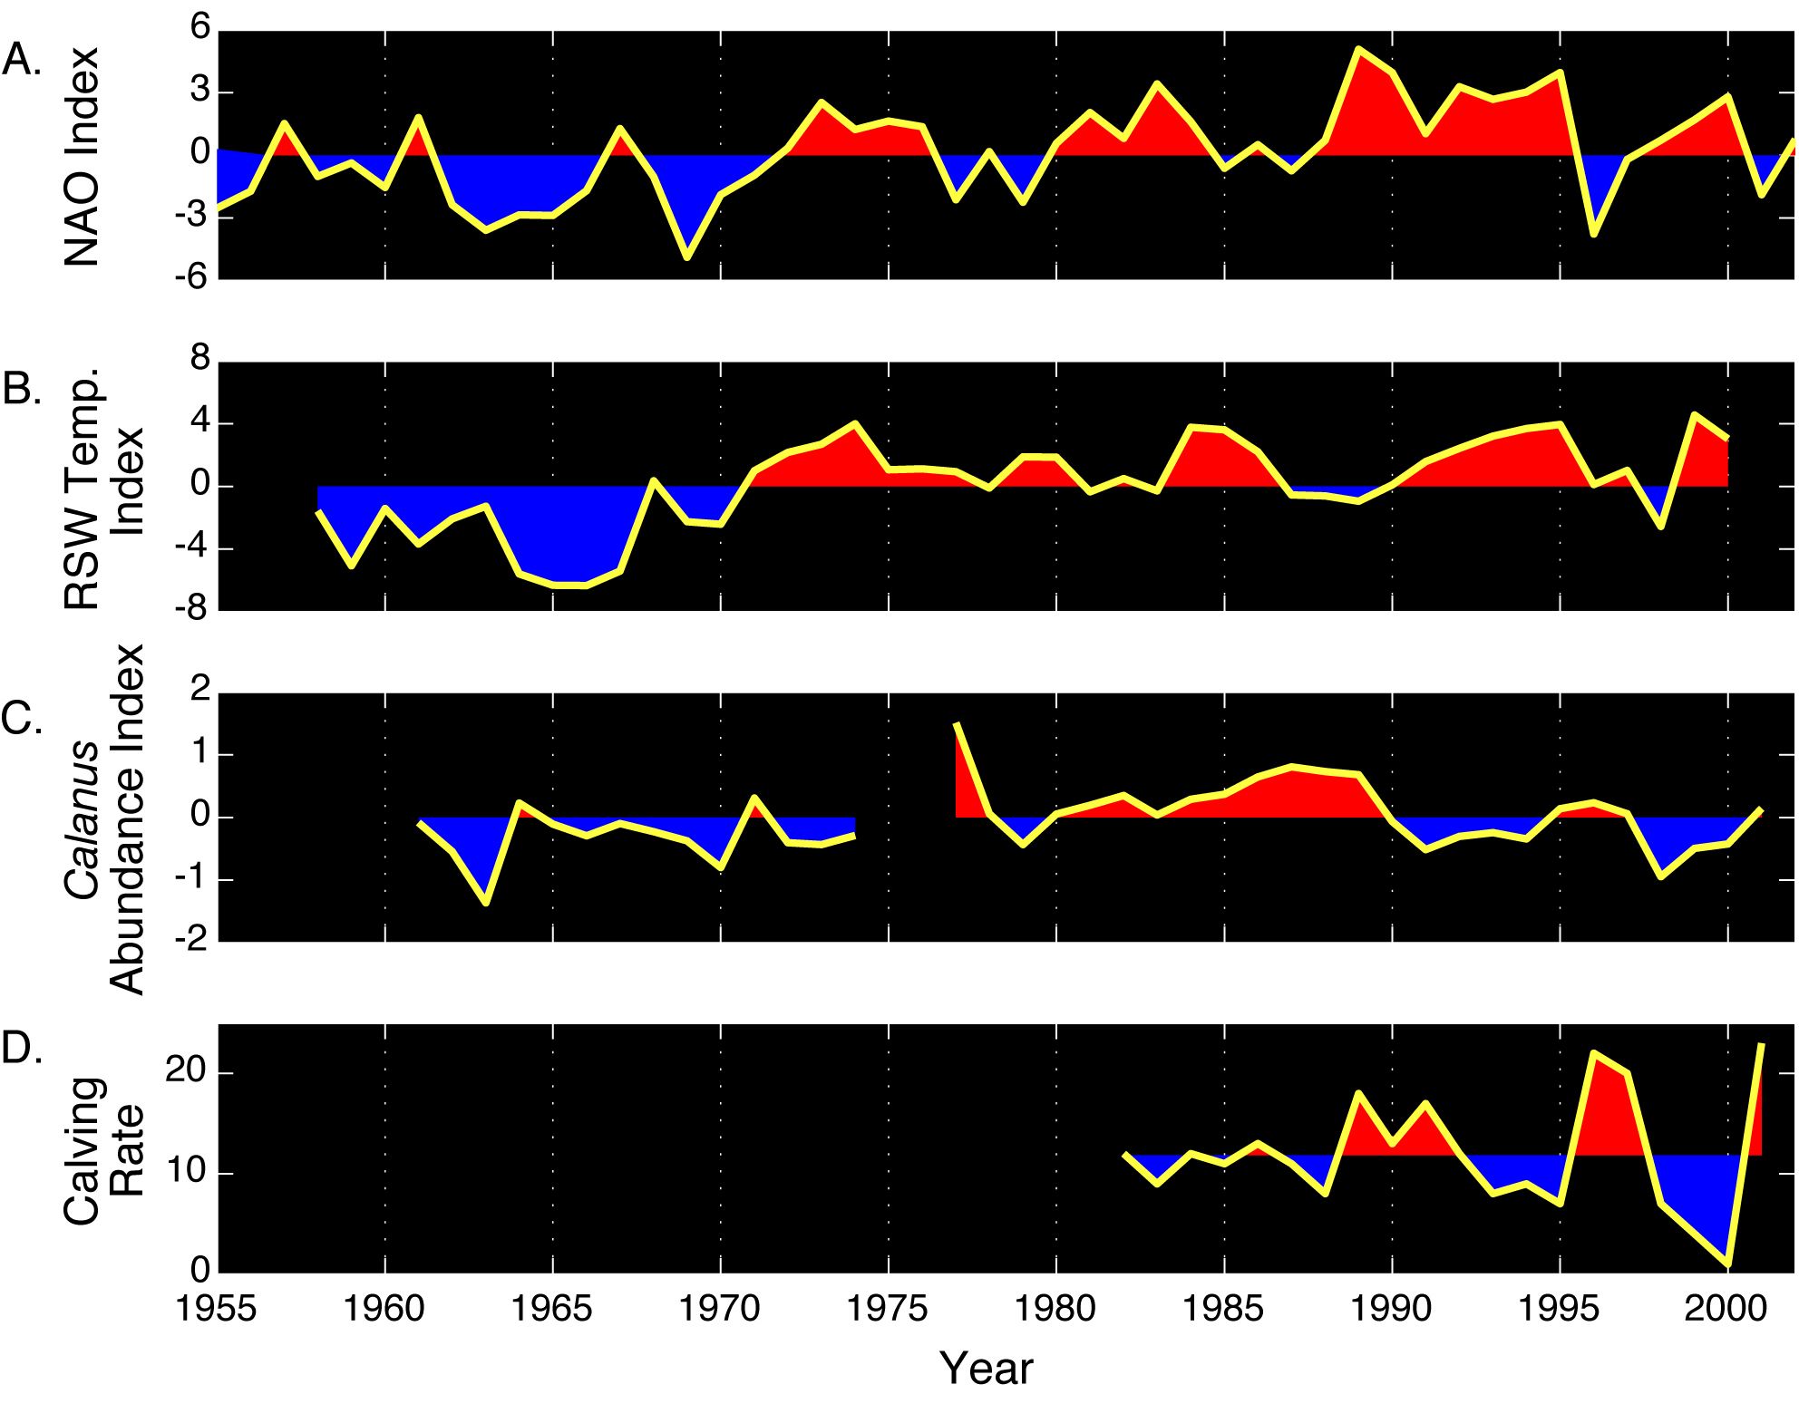

Figure 2. Time series from the North Atlantic. A.) Annual values of the NAO Index.
B.) Annual values of the Regional Slope Water (RSW) Temperature Index. C.) Annual values of the Calanus finmarchicus Abundance Index. D. Annual values of right whale calving rate. The winter NAO Index is the mean atmospheric pressure difference between the North Atlantic’s subtropical high-pressure system, measured in Lisbon, Portugal, and the subpolar low pressure system, measured in Stykkisholmer, Iceland (Hurrell, 1995). The RSW Temperature Index is an indicator of the modal state of the CSWS, with positive (negative) values corresponding to maximum (minimum) modal state conditions (MERCINA, 2001). It is the dominant mode derived from a principal components analysis of eight slope water temperature anomaly time series from the GOM/SS region. The Calanus finmarchicus Abundance Index is the mean abundance anomaly for this species calculated each year as the mean difference between log-transformed observed abundances and log-transformed expected abundances (MERCINA, 2001). Abundance data were derived from Continuous Plankton Recorder (CPR) surveys conducted in the GOM since 1961. Right whale calving rate is the number of individually identified females accompanied by calves observed during a year beginning in December of the preceding calendar year (Greene et al., 2003).

In 1996, the NAO Index exhibited its largest single-year drop of the 20th century, attaining a negative value not seen since the 1960’s (Fig. 2A). This large drop in the NAO Index was followed over the next two years by a modal shift in the CSWS, with the Labrador Current intensifying and the LSSW steadily advancing along the shelf break, displacing ATSW offshore, and penetrating farther southwest into the MAB (Fig. 1A) (MERCINA, 2001). In addition to its advance along the shelf break, the LSSW also invaded the shelf waters of the SS, GOM, and GB. Cooler temperatures and lower salinities were observed throughout the region in 1998, especially in the deep-basin waters derived directly from slope-water incursions.

The hydrographic changes observed in the region during 1998 were short-lived, however. The large drop in the NAO Index during the winter of 1996 was a single-year event, and the Index returned to positive values for the remainder of the 1990’s. Similarly, the CSWS shifted back to its maximum modal state, with the Labrador Current weakening and the frontal boundary of the LSSW retreating northeastward along the SS. As the supply of LSSW to the region decreased, ATSW returned to its previous position adjacent to the shelf break. By the end of 1999, incursions of warmer, more saline ATSW into the region’s shelf waters, combined with local warming, returned hydrographic conditions to a state resembling that prior to the modal shift of the CSWS triggered by the 1996 drop in the NAO Index.

Although the NAO-associated changes in slope water circulation have been relatively well documented from the SS to GB, the same cannot be said for the freshening of shelf waters observed from Newfoundland to the MAB during the decade from the late 1980’s to the late 1990’s (Smith et al., 2001; Drinkwater et al., 2002; Mountain 2002; 2003). While the source of the low-salinity water responsible for this freshening is upstream of the SS, the relative contributions from shelf sources in Newfoundland or further north versus the Gulf of St. Lawrence have not been fully resolved (Drinkwater et al., 2002; Frank, 2003). In the proposed research, we will focus our working group’s attention on variability in the salinity and volume of shelf waters supplied to the SS, GOM, GB, and MAB from upstream sources. There are two hypotheses associated with the observed freshening of shelf waters that we plan to investigate. The first focuses on inter-decadal variability, hypothesizing that the quasi-decadal salinity anomalies in the Labrador Sea, including the Great Salinity Anomaly of the 1970’s (Belkin et al., 1998) and the comparably strong salinity anomaly of the 1990’s (Hakkinen, 2002), enhance the supply of cooler and fresher Scotian Shelf Water (SSW) to the GOM, which, in turn, leads to the decadal-scale freshening and larger volume of Middle Atlantic Bight Shelf Water (MABSW) observed downstream (Mountain 2002; 2003). The second focuses on inter-annual variability, hypothesizing that phase shifts in the NAO affect the volumes and hydrographic properties of both SSW and slope water supplied to the GOM, which, in turn, leads to the year-to-year hydrographic and volume differences in the MABSW observed downstream. Determining the validity of both hypotheses will be important as we examine the implications of this lower salinity water on vertical stratification and production processes in the GOM and on GB. It will also be important as we extend our ecosystem studies to the MAB since the supply of MABSW formed in the GOM influences the position of the MAB shelf-slope front and the volume of environmentally suitable habitat on the shelf for cooler water species at the southern limits of their range.

Hydrographic data for the time-series analyses used to explore the above hypotheses will be drawn from the databases maintained by the NOAA Oceanographic Data Center, Bedford Institute of Oceanography (BIO), and Northeast Fisheries Science Center’s (NEFSC’s) Ecosystems Monitoring Group (Petrie et al., 1996; Hakkinen et al., 2002; Mountain 2002; 2003). Analyses of these hydrographic data will be supplemented with analyses of satellite altimetry and ice data. A graduate research assistant from Cornell, Ms. Louise McGarry, will conduct the hydrographic time-series analyses under the supervision of Dr. David Mountain, Woods Hole NEFSC, Dr. Peter Smith, BIO, and Dr. Sirpa Hakkinen, NASA Space Flight Center. Dr. Bruce Monger, Cornell, will work with Dr. Hakkinen on the analysis of satellite altimetry and ice data.

We anticipate using the results from these analyses of hydrographic and satellite data to provide the foundation for future modeling and observational studies. Dr. Hakkinen currently runs an Arctic-North Atlantic circulation model, based on the Princeton Ocean Model, which is forced by appending atmospheric anomalies from the NCEP/NCAR Reanalysis to a monthly climatology (Hakkinen, 1999). The model has been shown to simulate the salinity anomalies characteristic of the 1970s and 1990s, reproducing the effects of southward current anomalies and reduced meridional overturning on the downstream hydrography (Hakkinen, 2002). Our research team will investigate the feasibility of coupling such climate-forced, basin-scale circulation models with the kind of regional-scale, physical-biological models currently used by US GLOBEC investigators (reviewed by Hofmann and Lascara, 1998). This coupling of basin- and regional-scale models can only achieve its full potential if it is accompanied by the collection and analysis of new observational data, especially the hydrographic data collected in Canadian waters by the Department of Fisheries and Oceans (DFO) Canada. Dr. Peter Smith, Ocean Sciences Division Manager, and John Loder, Ocean Circulation Section Head, at BIO will participate as the DFO Canada physical oceanography representatives on our research team. Their knowledge of the regional oceanography and available data sets will be invaluable to our efforts.

Hypothesis 2: Remote forcing from the Labrador Sea impacts ecosystem processes not only in the SS/GOM/GB region but also in the Middle Atlantic Bight (MAB).

The NAO-associated changes in ocean circulation patterns observed over the past 40 years have had a profound impact on marine ecosystems from the SS to GB (Greene and Pershing, 2000; Conversi et al., 2001; MERCINA, 2001; 2003; 2004; Piontkovski and Hameed, 2002; Drinkwater et al., 2003; Pershing et al., 2004; Sameoto, 2001; 2004). The springtime zooplankton biomass and secondary production in this region is dominated by the copepod species Calanus finmarchicus. An annual C. finmarchicus Abundance Index, derived from continuous plankton recorder (CPR) surveys conducted in the GOM, provides a good indicator of changes in the modal state of the CSWS (Fig. 2B, C) (Greene and Pershing, 2000; MERCINA, 2001; 2003). During the decade of the 1960’s, when the NAO Index was predominantly negative, and the CSWS was in its minimum modal state, slope water temperatures and C. finmarchicus abundance were relatively low. During the 1980’s, when the NAO Index was predominantly positive and the CSWS was predominantly in its maximum modal state, slope water temperatures and C. finmarchicus abundance were relatively high. During each of the maximum- to minimum-modal shifts in the CSWS after 1980, C. finmarchicus abundance declined in subsequent years. The modal shift during 1981-83 preceded a large, single-year decline in abundance during 1983. The modal shift during 1988-91 preceded a large decline in abundance that persisted throughout the early 1990’s. Then, after C. finmarchicus abundance began building up again during the mid-1990’s, the NAO Index underwent its drop of the century in 1996. This event triggered the intense modal shift of the CSWS during 1997, which, in turn, led to very low abundances of C. finmarchicus during 1998 and early 1999. The mechanisms underlying these climate-driven changes in C. finmarchicus abundance have not been fully resolved; however, they appear to be linked to the advective supply of this species into the GOM/SS region from the slope waters (Greene and Pershing, 2000; MERCINA, 2001; 2003; 2004).

Marine ecosystem responses to NAO-associated oceanographic changes also have been detected at trophic levels both lower and higher than the one occupied by C. finmarchicus. A time series of the Spring Phytoplankton Color Index, a qualitative measure of phytoplankton standing stock, was analyzed by Pershing (2001) using the same CPR survey dataset as the one used to derive the C. finmarchicus Abundance Index. He was able to show that this admittedly crude index of standing stock exhibits many features in common with the C. finmarchicus Abundance Index, including low values in the 1960’s and high values in the 1980’s. Pershing (2001) hypothesized that these changes in the Spring Phytoplankton Color Index reflect modal shifts in the CSWS and nutrient limitation of phytoplankton production. This hypothesis is consistent with differences in nutrient concentrations associated with the two slope water types, as ATSW is characterized by high concentrations of nitrate and silica, and LSSW is characterized by low concentrations of these nutrients (Petrie and Yeats, 2000). It appears that the elevated nutrient concentrations in ATSW are the result of Gulf Stream cross-frontal exchange processes bringing nutrients to the Slope Water Sea from the deep subsurface waters of the Sargasso Sea (Schollaert et al., 2004).

With regard to higher trophic levels, we have developed a stochastic model showing that most of the variability in right whale calving rates can be explained by NAO-associated fluctuations in C. finmarchicus abundance (Fig. 2, 3) (Greene et al., 2003; Greene and Pershing, 2004). The calving rates predicted by this model capture the overall patterns very well, especially the large fluctuations of recent years. Both multi-year declines observed during the early 1990’s were reproduced by the model. In addition, it accurately predicted the dramatic increase in right whale calves born during 2001. These results have given us confidence in the model’s predictive capability, not only to hindcast past events, but also to forecast right whale reproductive performance at least one year into the future.

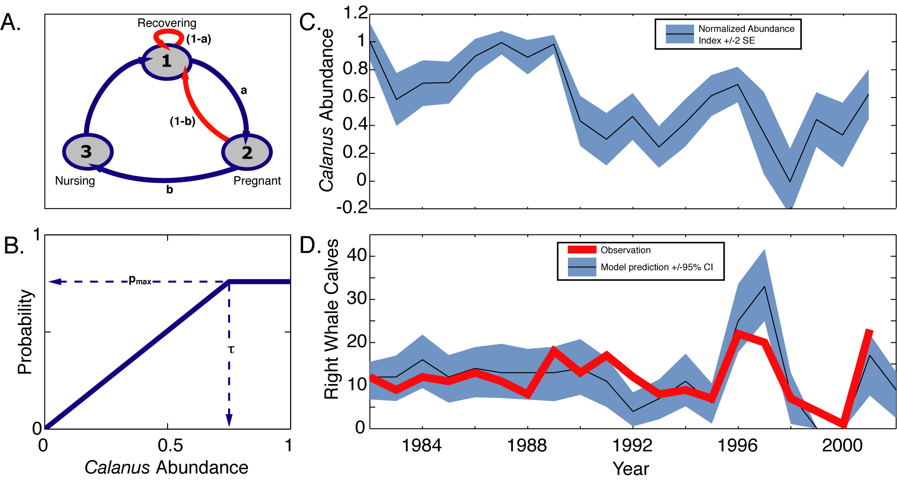

Figure 3. Right whale reproduction model. A. Diagram of reproductive cycle, with transitional probabilities between states indicated. A whale in any of the three states, pregnant, nursing, or recovering, will move to the next state with a probability determined by Calanus finmarchicus abundance in that year. B. The transitional probabilities are simple functions of Calanus finmarchicus abundance as described by the parameters, τ, the saturating food level, and p_{max}, the maximum transitional probability. C. The Calanus finmarchicus Abundance Index as determined from Continuous Plankton Recorder surveys in the Western GOM. D. Number of right whale calves observed and predicted by the model. The shaded region encompasses the 95% confidence interval surrounding the model predictions (Redrawn from Greene et al., 2003) .

As we look to expand the scope of our research beyond the NAO and beyond the SS/GOM/GB region, we will once again turn our attention to the analysis of existing time-series data sets. A recent principal components analysis of CPR zooplankton time-series data from the GOM has shown that several copepod species (Centropages typicus, Oithona sp., Pseudocalanus spp., and Metridia lucens) exhibit a mode of variability in abundance that is distinctly different from the one exhibited by C. finmarchicus (Pershing et al., 2005). In contrast to C. finmarchicus, these species increased dramatically in abundance from the late 1980’s until a rapid decline occurred in 2002. Pershing et al. (2005) hypothesized that the assemblage of copepod species exhibiting this mode of variability may have been responding to the decade-long freshening of the Northwest Atlantic shelf described previously, with its associated enhancement of winter-time stratification and primary production (Durbin et al., 2003).

We propose to follow up on these earlier studies by conducting comparable principal components analyses of zooplankton time-series data from the MAB to Newfoundland. We hypothesize that the copepod abundance patterns observed in other regions (i.e., MAB, Newfoundland, SS) will exhibit modes of variability similar, but perhaps of different magnitudes, to the ones observed in the GOM. Data for these analyses will come from CPR surveys conducted along the New York-Bermuda transect line since 1971, from bongo net samples collected during shelf-wide research vessel surveys conducted from Cape Hatteras, NC to Cape Sable, NS since 1977, and from CPR surveys conducted along the E-Line from New England to Newfoundland during 1961-1976 and 1991-2004 (Sameoto, 2001; 2004). The New York-Bermuda CPR and shelf-wide bongo net data were collected originally as part of the NEFSC’s Marine Resources Monitoring, Assessment, and Prediction (MARMAP) Program. The NEFSC’s Ecosystems Monitoring Group continues to collect and archive these data. We have established an excellent record of collaboration with scientists working in this group, and have complete access to the archived data sets (see letter of support). Drs. Erica Head and Doug Sameoto, BIO, have collaborated with us in previous MERCINA working group meetings (MERCINA, 2001; 2003), and will take responsibility for analyzing the E-Line CPR data set as part of our research team.

In addition to analyzing zooplankton data, we propose to analyze Phytoplankton Color Index data from the New York-Bermuda transect CPR surveys and chlorophyll fluorescence data from the shelf-wide research vessel surveys. We also intend to analyze satellite ocean color data from the Sea-viewing Wide Field-of-view Sensor (SeaWiFS) mission. Dr. Bruce Monger and several NASA Space Grant-supported students at Cornell have conducted comparable studies in the SS/GOM/GB region since the launch of the SeaWiFS sensor in 1997, and the proposed effort simply expands the domain of these studies to include the MAB. Ms. Yianna Samuel, a graduate student at Cornell, will assist Dr. Monger with the expanded effort. We have found evidence in the SS/GOM/GB region that phytoplankton production and the seasonal cycle may be altered by NAO-associated changes in nutrient supply and salinity-anomaly-induced changes in the timing of stratification (Pershing, 2001; MERCINA, 2004). We hypothesize that analyses of in situ and satellite data will reveal comparable responses of phytoplankton primary production to climate-associated changes in hydrography and circulation in the MAB.

D. Broader Impacts
Climate and Ecosystem-Based Resource Management

A major goal of our project is to develop a predictive understanding of climate impacts on marine ecosystems in the Northwest Atlantic that will enable us to provide operational input to the managers of living marine resources. By focusing on physical and biological processes with strong links to climate and significant time lags, we anticipate being able to construct models that can forecast such changes with lead times ranging from a few months to as long as two years. Such an operational capability, combined with our close ties to NOAA’s Regional Fisheries Science Centers, will enable us to provide that agency’s policy makers and resource managers with the means to make better informed decisions affecting both exploited as well as protected marine species. It also will enable these managers to develop stock-rebuilding and conservation plans that are in compliance with the Magnuson-Stevens Fisheries Conservation Act and Marine Mammal Protection Act. Our results will be disseminated through freely available models and data products, publications in peer-reviewed journals, and presentations in dedicated special sessions at national meetings.

Recently, two members of our research team (CHG and AJP) submitted a proposal to the National Center for Ecological Analysis (NCEAS) seeking support for an international working group (WG) charged with assessing different methods for incorporating climate-associated environmental variability into fisheries recruitment models. We intend to develop a close relationship between the regional WG assembled for the project proposed here (Table 1) and the international WG assembled for the NCEAS project (Table 2). The success of the international effort will depend on the NCEAS WG’s ability to develop a global perspective by synthesizing results from a variety of regional studies. Similarly, the success of the regional effort will depend on our WG’s ability to not only identify patterns, processes, and mechanisms of specific regional importance, but also to elucidate ones that can be generalized to ecosystems in other regions.

In making the leap from documenting climate-associated ecosystem responses to forecasting the future of managed populations, care must be taken to account for the ecological mechanisms linking the demography of these species to the ecosystem. For exploited fish populations, single-species fisheries management typically has involved setting catch limits based on environmentally invariant stock-recruitment models. In contrast, ecosystem-based fisheries management requires the development of models that can predict recruitment from stock assessment data combined with data on environmental variability.

To illustrate one method for incorporating climate-associated environmental variability into fisheries recruitment models, we briefly describe two recent studies by Brodziak et al. (2005) and Pershing et al. (2005). These authors, which include invited participants to our proposed NCEAS WG, used the following standardized recruitment model to distinguish between factors internal to the population and those arising from external environmental forcing:
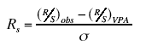 (1)
where R_{s} is the standardized recruit per spawner index, R and S are the recruitment and spawning stock biomass inferred from observations (subscript obs) and the virtual population assessment (subscript VPA), respectively, and 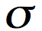 is the standard deviation of the observed-VPA series. The standardized recruitment model subtracts the component of recruitment due to internal population factors from the observed recruitment, leaving as a remainder the component due to external environmental forcing.

Brodziak et al. (2005) showed that time series of R_{s} for eight of 12 commercially important fish stocks investigated in the GOM/GB region exhibited significant, time-lagged cross correlations with the NAO Index time series. Their preliminary results suggest that the external, environmentally forced recruitment of these stocks may be linked to physical and/or biological processes responding to NAO forcing.
Pershing et al. (2005) took a different approach to the problem and drew conclusions that, at first, appear to be somewhat at odds with those of Brodziak et al. (2005). First, these authors used principal components analysis to establish two distinct modes of zooplankton variability (the “C. finmarchicus” mode, the “other copepods” mode) and related these to the two climate-associated changes in regional physical oceanography described previously (the NAO-forcing of the CSWS and the 1990’s decadal freshening from upstream). They then conducted cross-correlation analyses between time series of the zooplankton modes of variability and time series of R_{s} for the same 12 fish stocks studied by Brodziak et al. (2005). Results from the analyses conducted by Pershing et al. (2005) indicate that the decadal freshening of the region during the 1990’s had a greater impact on more copepod species and fish stocks than the changes brought about by NAO forcing. The results from these two studies are compatible when one recognizes that zooplankton need not be mediating the statistical associations between NAO forcing and fish recruitment reported by Brodziak et al. (2005). For fish stocks, like GB haddock, in which the time series of R_{s} is positively cross correlated with time series of both the NAO Index and the mode of zooplankton variability linked to NAO forcing, the results might encourage further investigation of hypotheses linking C. finmarchicus abundance to GB haddock recruitment success. For the other fish stocks, with time series positively cross-correlated with NAO Index but not with the “C. finmarchicus” mode, it may be more productive to explore other types of hypotheses first. The purpose of highlighting these two studies here is to illustrate the kind of insights and synergy that can emerge by assembling WGs composed of oceanographers, fisheries scientists, and fisheries managers. The broader perspective of such multidisciplinary WGs frequently leads to the formulation of more thought-provoking hypotheses and eventually a deeper understanding of the processes regulating fish abundance in the sea.
Table 1. Northwest Atlantic Regional Working Group:
1. Ted Durbin, Biological oceanography, School of Oceanography, University of
Rhode Island, Narragansett, RI USA edurbin@gsosun1.gso.uri.edu
2. Charles Flagg, Physical Oceanography, Marine Science Research Center,
State University of New York, Stony Brook, NY USA cflagg@ms.cc.sunysb.edu
3. Charles Greene, Biological oceanography, Ocean Resources & Ecosystems
Program, Cornell University, Ithaca, NY USA chg2@cornell.edu
4. Sirpa Hakkinen, Physical oceanography, Goddard Space Flight Center,
Greenbelt, MD USA sirpa.m.hakkinen@nasa.gov
5. Erica Head, Biological oceanography, Bedford Institute of Oceanography,
Halifax, Nova Scotia, Canada heade@mar.dfo-mpo.gc.ca
6. John Loder, Physical oceanography, Bedford Institute of Oceanography,
Halifax, Nova Scotia, Canada loderj@mar.dfo-mpo.gc.ca
7. David Mountain, Physical oceanography, National Marine Fisheries Service,
Woods Hole, MA USA david.mountain@noaa.gov
8. Bruce Monger, Biological oceanography, Ocean Resources & Ecosystems
Program, Cornell University, Ithaca, NY USA bcm3@cornell.edu
9. Andy Pershing, Biological oceanography, Ocean Resources & Ecosystems
Program, Cornell University, Ithaca, NY USA ajp9@cornell.edu
10. Doug Sameoto, Biological oceanography, Bedford Institute of Oceanography,
Halifax, Nova Scotia, Canada sameotod@mar.dfo-mpo.gc.ca
11. Peter Smith, Physical oceanography, Bedford Institute of Oceanography,
Halifax, Nova Scotia, Canada smithpc@mar.dfo-mpo.gc.ca

Table 2. NCEAS International Working Group:
1. Barbara Bailey, Biostatistics, Department of Statistics, University of Illinois
at Urbana-Champaign, IL USA babbailey@stat.uiuc.edu
2. Gregory Beaugrand, Biological oceanography, Station Marine, Université des Sciences et Technologies de Lille, France gregory.beaugrand@univ-lille1.fr
3. Jon K.T. Brodziak, Fisheries management, National Marine Fisheries Service,
Woods Hole, MA USA jon.brodziak@noaa.gov.org
4. Francisco Chavez, Biological oceanography, Monterey Bay Aquarium Research Institute, Moss Landing, CA USA chfr@mbari.org
5. Brad de Young, Physical oceanography, Department of Physics and Physical Oceanography, Memorial University, Canada bdeyoung@physics.mun.ca
6. Ken Drinkwater, Biological oceanography, Institute of Marine Research,
Bergen, Norway ken.drinkwater@imr.no
7. Charles Greene, Biological oceanography, Ocean Resources & Ecosystems Program, Cornell University, Ithaca, NY USA chg2@cornell.edu
8. Steven Hare, Fisheries, International Pacific Halibut Commission
Seattle, WA USA hare@iphc.washington.edu;
9. Lew Incze, Biological oceanography, Bioscience Research Institute, University of Southern Maine, ME USA lincze@usm.maine.edu
10. Geir Ottersen, Biological oceanography, Institute of Marine Research, Bergen, Norway geir.ottersen@bio.uio.no
11. Andy Pershing, Biological oceanography, Ocean Resources & Ecosystems
Program, Cornell University, Ithaca, USA ajp9@cornell.edu
12. P. Christopher Reid, Biological oceanography, Sir Alister Hardy Foundation for Ocean Science, Plymouth, United Kingdom pcre@sahfos.ac.uk
13. David Welch, Fisheries oceanography, Pacific Biological Station, Nanaimo, Canada welchd@pac.dfo-mpo.gc.ca

Educational Impacts

A significant portion of the funds requested in this proposal will be used to support the training of two graduate students, Ms. Louise McGarry and Ms. Yianna Samuel. Ms. McGarry participated as a research technician in all of our GLOBEC NWA autumn cruises to the GOM during the late 1990’s. She also participated in several GLOBEC NWA scientific investigator meetings during and subsequent to the field program. The relatively large allocation of the requested funds to support graduate students is consistent with our commitment to integrating education with research. During the past decade, in addition to the educational outcomes cited in Results from Prior NSF Support, two members of our research team (CHG and BCM) have run advanced courses in bioacoustical and satellite oceanography that have trained more than 150 students from greater than 20 countries. Female graduate students consistently have been given prominent leadership roles in these courses. The support requested here for Ms. McGarry and Ms. Samuel, teaching assistants in three of these courses since starting graduate school, will enable us to continue providing them with exceptional learning opportunities during the remainder of their graduate educations.

In addition to graduate education, we will continue to involve undergraduates in our research, just like the seven supervised during our previous US GLOBEC studies.
E. Project Organization and Time Table

Drs. Charles Greene and Andrew Pershing will serve as the project’s principal investigators, sharing in the responsibilities of organizing working group meetings, overseeing the research team’s activities, and supervising the graduate research assistants. Drs. Hakkinen, Monger, and Mountain will serve as senior personnel on the research team, overseeing the research issues outlined on p. 8 of the proposal. Drs. Loder, Head, Smith, and Sameoto also will serve as participants on the research team and have responsibility for several of the research issues outlined on p. 8 and 10 of the proposal. The remaining working group members (see Table 1) will participate in the regional meetings (see Table 3) where they will work with the research team to steer the research agenda and assist in the interpretation of results.

Table 3. Time Table

ACTVITY TOPICS _____________ TIME_______

First Regional WG Meeting Autumn 2005
- Review Previous Work Related
to Hypotheses One and Two
- Assignment of Research Tasks
- Plan AGU/ASLO Special Session Talks

First NCEAS WG Meeting Autumn 2005
- Review of Analytical Methods
- Identification of New Data Sets
- Assignment of Research Tasks
- Plan AGU/ASLO Special Session Talks

Data Analyses Autumn 2005 – Summer 2006

Proposed Special Session: AGU/ASLO Ocean Sciences Meeting Winter 2006

Second Regional WG Meeting Autumn 2006
- Reports on Research Accomplishments
- Planning Publications/Other Products
- Assignment of New Research Tasks
- Plan AAAS Special Session Talks

Second NCEAS WG Meeting Autumn 2006
- Reports on Research Accomplishments
- Planning Publications/Operational Products
- Assignment of New Research Tasks
- Plan AAAS Special Session Talks

Special Session: AAAS Annual Meeting Winter 2007

Data Analyses, Manuscript Preparation Autumn 2006 – Summer 2007

Combined Regional and NCEAS WG Meeting Autumn 2007
- Reports on Research Accomplishments
- Complete Publications/Operational Products

